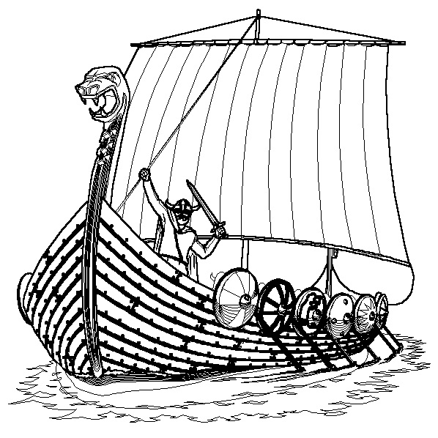
Treasurer
6 Pollok Place,
Thurso,
KW14 7QL
pentlandfirthyc@gmail.com
www.pentlandfirthyachtclub.org.uk

Please Complete this form and return, by post or email, to the club treasurer along with payment in either cash or bank transfer. To ensure the Club holds accurate data and privacy consents for all members, all membership forms are destroyed after 3 years.
Name 1
Email 1 |  |  | Phone 1
Name 2
Email 2 |  |  | Phone 2
Address
Postcode |  |  | Landline

Please enter the names and date of birth of all members under 18 on 1st November 2024 below
Junior Name(s)
Date of Birth

Membership Categories
Type | Fee | Description | Tick ()
Adult | £85 | An Adult is a FULL member entitled to take part in all activities and to use all amenities of the club
Family | £120 | Two Parents/Guardians as Full members and children under the age of 18 as Junior members.
Student/Eligible for State Pension/Unemployed | £50 | As a FULL member.
Junior (Under 18) | £30 | AS a FULL member except that they shall not be eligible for membership of the committee or to vote at General Meetings except as stated in paragraph 18 of the Constitution.
Cruising | £45 | As a FULL member except not eligible to take part in races or any events organised by the Club unless specifically for Cruising Members.
Swimmer/Watersports | £35 | Full use of Club Facilities  (Excluding Garage)  No rights except attendance at social and general meetings of the club.
Associate | £10 | No rights except attendance at social and business meetings of the club. They shall make no other use of the club facilities except when providing support for events.
Weekend | £5 | As JUNIOR member for one weekend only. For a maximum of 3 weekends per season.
Membership taken from 1st August will be eligible to a reduction of 50% of the above fees, excluding Weekend Membership.
Boat Storage
There is an additional charge for boatowners to store their boats in the PFYC compound as well as a charge for leaving road trailer bases within the compound. The prices are as below:
Type | Fee | No. of Boats/Trailers
Boat Storage – Small (<12ft) | £60
Boat Storage – Large (>12ft) | £75
Trailer Storage* | £5
* In Small Compound. Trailers stored in bay below boat are covered with Boat Storage.
Boat Details
Vessel Name | Boat Class | Sail Number

Trailer Details
Trailer Brand | Trailer Serial Number | Any Other Identifiable Details

Declaration – BOAT OWNERS ONLY
The safety of the dinghy/cruiser and its management is the responsibility of the owner/sailor. The Penland Firth Yacht Club neither limits nor reduces the complete and unlimited responsibility of the owner/sailor who must have a minimum of £2,000,000 Third Party Liability Insurance for their craft, including boats in storage.
I/We confirm that I/we shall maintain insurance for any boat owned or part-owned by me/us until such time as I/we have submitted a withdrawal in writing to the club treasurer.

Annual Club Boat Hire Fee
There is an additional charge for the hire of club boats. The fee is set as a flat rate or will be charged at £5 per boat if no flat rate has been selected.
Type | Fee | No. of Club Hire Fees
Boat Hire | £50

Total Fees Payable
Membership | Boat/Trailer Storage | Total
£ | £ | £

Payment
I/we have signed this membership form and have made payment through cash/cheque enclosed or bank transfer (Delete as Appropriate)
Sort Code | 83-27-23
PFYC Account Number | 00235157
Account Name | Pentland Firth Yacht Club

Please ensure your name is given when transferring funds and are using correct account number.
DECLARATION – ALL MEMBERS
I/we understand that sailing and other water sports have their attendant risks. By signing this form, I/we agree to be bound by the “Club and Sailing Guidelines and Rules” and Club Constitution. A copy of the Club and Sailing Guidelines and Rules along with the Club Constitution is kept in the club house and is available on request.
I/we acknowledge that I/we am/are bound by the rules and constitution of the Club regardless of whether I/we have paid the relevant membership fee.
I/we agree /disagree* that my contact details may be shared with other club members for the purposes of club communication, including being added into the relavant PFYC WhatsApp group(s).
I/we agree / disagree* that photographs taken in private at club events may be used for publicity purposes by Pentland Firth Yacht Club.
I/we agree /disagree* to the use of my/our child/rens’ image being used for publicity purposes by Pentland Firth Yacht Club.
*Please delete whichever does not apply, blank entries will be assumed to be “agree”
Club correspondence is generally by e-mail.

 | Print | Sign | Date
Member Name 1 (PRINT)
Member Name 2 (PRINT)
Name of Parent or Guardian (if applicable)

Members are required to read and adhere to the “Child Protection and Vulnerable Adult” policy.

How Can You Help the Club?

The Club is run entirely on a volunteering effort. We want all our members to be and feel able to volunteer for some type of duty or to assist in the running of the club. Please indicate below which duty or other form of assistance you wish to volunteer to do and what previous knowledge you have in the field on a scale of 1-10. Please feel free to volunteer for more than one duty if you feel able to do so.

Duty | Name/s | Tick () | Previous Knowledge
Social Event Organisation
Catering
Building Maintenance
Club Boat Maintenance
Guard boat Maintenance
Compound Maintenance
Communications
Club Development
Fundraising
Other

